

**SAP Technical Specification**

|  |  |
| --- | --- |
| Project | **HCM to MIM Interface** |
| Customer | **Serco** |
| Solution | **Technical Specification** |
| Version | **0.1** |
| Author | **Likita Cherukuri** |
| Date | **23.06.2020** |

Template Control

| Version | Date | Author | Notes |
| --- | --- | --- | --- |
| 0.1 | 13th August 2013 | Malcolm Smith | Created from existing templates |
| 1.0 | 4th Sept 2013 | John Brinkworth | First Issue |

Document Control

| Version | Date | Author | Notes |
| --- | --- | --- | --- |
| 0.1 | 23.06.2020 | Likita Cherukuri | Initial TS |
| 0.1 | 06.07.2020 | Sandeep Mishra | Reviewed |

Document Location

| Location |
| --- |
| To be uploaded on Ourworld – TBD (Update the link once documents is signed off and uploaded) |

Approval

| Name | Role | Date | Signature |
| --- | --- | --- | --- |
| Sandeep Mishra |  |  |  |

Distribution

| Name | Role |
| --- | --- |
|  |  |

Table of Contents

1 Overview 4

2 General Information 4

3 Selection Screen 4

4 Database Tables / Structures Used 4

5 Program Details 4

5.1 Solution Details 4

6 Test Evidence 5

7 Annex A – Product Description (reference only) 6

Table of Figures

**No table of figures entries found.**

Table of Tables

**No table of figures entries found.**

# Overview

This project is MIM as UAM replacement.

Microsoft Identity Manager (MIM) is a state-based identity management software product, designed to manage user’s digital identities, credentials and groupings throughout the lifecycle of their membership of an enterprise computer system.

In line with UAM, to facilitate the creation of user identities in MIM, HR data from SAP HCM system need to be interfaced to MIM. Employee (personal data) and Organisation (hierarchy) data for all the regions will be pulled from HCM to MIM system

# General Information

**Program Names:**

ZHCM_MIM_ORG_PROG

ZMIM_EMPDATA_UPDATE

ZMIM_EMPDATA_FULL_UPDATE

**Function Module:**

ZHCM_MIM_ORG

**Proxy Details:**

Namespace: SERCO_SOFTWARE_COMP, 1.0 of Serco

For Employee - Urn:Serco.com:interface_MIM_Employee

Service Interface: SI_HCM_Employees_Sync

For Org – Urn:Serco.com:interface_MIM_Organisation

Service Interface: SI_HCM_Org_new

**Class**:

ZCL_IM_HRALE00CHANGE_PTRS

# Selection Screen

No selection screen

# Database Tables / Structures Used

Tables: HRP1001,

HRP1000

PA0000,

PA0001,

PA0002,

PA0006,

PA0041,

PA0105,

ZMIM_ORG_TAB,

ZMIM_EMPDATA,

ZMIM_EMPDATAFULL.

# Program Details

## Solution Details

### Organisation (hierarchy) data

1. Go to SE38 and create a new program -

ZHCM_MIM_ORG_PROG

Call function module ZHCM_MIM_ORG

1. Get SAP Organisation Node ID, Start Date of Org Unit, End Date of Org Unit, Status, Short text & long name (Division) from HRP1000 table
2. Get Object ID and get Primary Manager, Manager EPN & Molga from HRP1001 table for B012 relationship
3. Get Object ID and get Primary Manager, Manager EPN & Molga from HRP1001 table for A002 relationship if B012 relationship doesn’t exists.
4. Get Name of HR Country Grouping from T500T table.
5. FM - RH_GET_LEADER is used to get primary manager, RH_PM_GET_MOLGA_FROM_PERNR to get country grouping & HRHAP_SEL_ORG_UNIT_OF_ORG_UNIT to get parent org unit.
6. Data will be fetched to lt_zmim_org & updated to table ZMIM_ORG_TAB.
7. Get data from ZMIM_ORG_TAB into lt_org, loop the data and pass into PI structure output-mt_hcm_res_org_new-org_employee.

### Employee (personal data) FULL Employee extract

1. Go to SE38 and create new program –

ZMIM_EMPDATA_FULL_UPDATE

Create Includes

ZMIM_EMPDATA_FULL_UPDATE_TOP – Include for data declarations

ZMIM_EMPDATA_FULL_UPDATE_FORM – Include for Subroutines

1. In PERFORM get_data all the table data will fetched. In ZPARAMS table maintain number of days from the system date to fetch future hire latest record into lv_value.

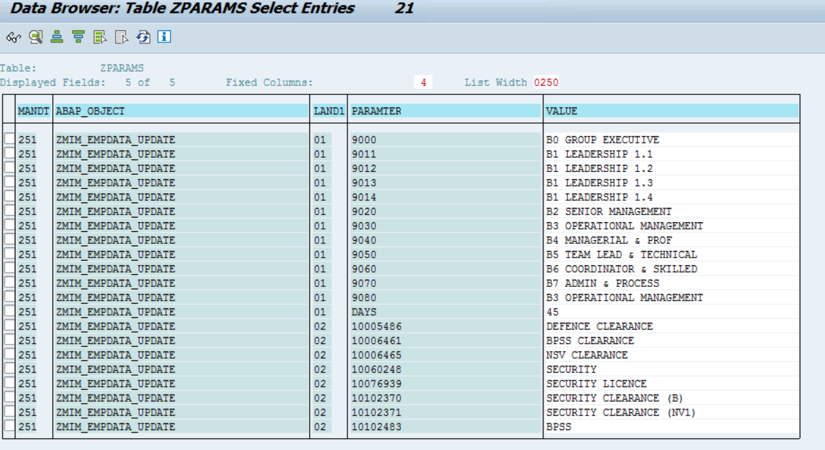

1. Get End Date, Start Date, Action Type, Reason for Action, Employment Status from PA0000 table into it_pa0000.
2. Get Employee Last name, Employee Birth name, Employee First name, Employee Nickname, Employee Middle name & Form-of-Address Key from PA0002 table into it_pa0002
3. Get Form-of-Address Key, Form-of-Address Key-text from table t522t into table it_t522t.
4. Get Business Sector, Staff Type, Personnel Area, Organizational Unit, position, persona code from table PA0001 into it_pa0001 & get persona code from table HRP1010 into it_hrp1010 for position from it_pa0001.
5. Get Region from table PA0006 into table it_pa0006 & get Contract End Date from table PA0016 into it_pa0016.
6. Get Cost Centre from PA0315 into it_pa0315 & prctr from CSKS table into it_csks
7. Get WBS Element from PA0027 into it_pa0027 & profit centre for WBS from PRPS table into it_prps.
8. Get User ID, telephone number from table PA0105 into it_pa0105_50 for subtype ‘0050’, ‘CELL’, ‘WMOB’.
9. Get Division entry date from PA0041 into it_pa0041 & FM - HR_ECM_GET_DATETYP_FROM_IT0041 is used to fetch division entry date by passing start date & pernr from pa0041.
10. Get Vetting/Security Clearance Status, Leadership Grade from tables HRP1002 into it_hrp1002 & T777U into it_t777u. These will be maintained in ZPARAMS table.
11. Get Building from HRP1028 table into it_hrp1028 & Street and House Number, city, Country Key from table T777U into it_t777a.
12. Get Position Name from table HRP1000 into it_hrp1000 & persona text from T777W into it_t777w. Get Manager EPN from table from table HRP1001 into it_hrp1001
13. Get Manager EPN from table HRP1001 into it_hrp1001.
14. Data sending to the work area process only active records from IT_PA0000

ls_empdatafull-pernr = wa_pa0000-pernr.

ls_empdatafull-begda = wa_pa0000-begda.

ls_empdatafull-endda = wa_pa0000-endda.

ls_empdatafull-stat2 = wa_pa0000-stat2.

ls_empdatafull-massn = wa_pa0000-massn.

ls_empdatafull-massg = wa_pa0000-massg.

Get leaving date using FM HR_LEAVING_DATE based on pernr

ls_empdatafull-leave_date = lv_date + 1.

ls_empdatafull-werks = wa_pa0001-werks.

ls_empdatafull-persg = wa_pa0001-persg.

ls_empdatafull-orgeh = wa_pa0001-orgeh.

ls_empdatafull-gsber = wa_pa0001-gsber.

Get division using FM RH_STRUC_GET

ls_empdatafull-division = wa_objec-stext.

ls_empdatafull-stext_quali = wa_zparams-value.

ls_empdatafull-state = wa_pa0006-state.

ls_empdatafull-hilfm = wa_hrp1010-hilfm.

ls_empdatafull-htext = wa_t777w-htext.

ls_empdatafull-build = wa_t777a-stext.

ls_empdatafull-strs2 = wa_t777a-strs2.

ls_empdatafull-ort01 = wa_t777a-ort01.

ls_empdatafull-land1 = wa_t777a-land1.

ls_empdatafull-leadership_grade = wa_zparams-value.

ls_empdatafull-manager = gc_x .

Get manager EPN using FM ZHCM_LINE_MANAGER_MIM

ls_empdatafull-manager_epn = ls_managers-pernr.

ls_empdatafull-nachn = wa_pa0002-name2.

ls_empdatafull-nachn = wa_pa0002-nachn.

ls_empdatafull-vorna = wa_pa0002-vorna.

ls_empdatafull-midnm = wa_pa0002-midnm.

ls_empdatafull-rufnm = wa_pa0002-rufnm.

ls_empdatafull-atext = wa_t522t-atext.

ls_empdatafull-ctedt = wa_pa0016-ctedt.

ls_empdatafull-kostl = wa_pa0315-kostl.

ls_empdatafull-prctr = wa_csks-prctr.

ls_empdatafull-prctr = wa_csks-prctr.

ls_empdatafull-posid = lv_wbs.

ls_empdatafull-usrid = wa_pa0105_50-usrid.

ls_empdatafull-telephone_no = wa_pa0105_50-usrid.

ls_empdatafull-dat01 from FM - HR_ECM_GET_DATETYP_FROM_IT0041

ls_empdatafull-molga = lv_molga

ls_empdatafull-wfm = lc_roster.

ls_empdatafull-wfm = lc_non_roster.

Append the entries to lt_empdatafull & update staging table zmim_empdatafull

1. Clear & Refresh the work area & internal table whenever required. Also sort the internal tables where required & also can use binary search where required.
2. In proxy we get the data from table zmim_empdatafull into lt_mim_empdatafull & send it to PI structure output-mt_hcm_res-employee for request ‘F’.

### Employee (personal data) DELTA Employee extract

1. Go to SE38 and create new program –

ZMIM_EMPDATA_UPDATE

Create Includes

ZMIM_EMPDATA_UPDATE_TOP – Include for data declarations

ZMIM_EMPDATA_UPDATE_FORM – Include for Subroutines

1. In PERFORM get_data all the table data will fetched. In ZPARAMS table maintain number of days from the system date to fetch future hire latest record into lv_value.
2. In table ZPARAMS table infotypes are maintained for which the changes on that infoypes to any PERNR will be updated through the Class - **ZCL_IM_HRALE00CHANGE_PTRS** into table ZMIM_EMPDATA with PERNR, system date & system time.

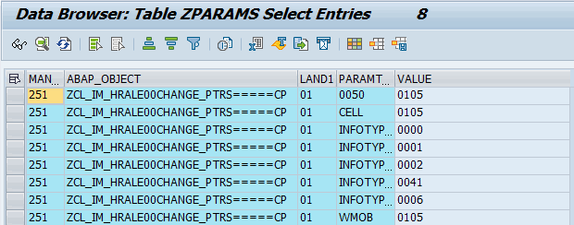

1. Get the PERNRs from table ZMIM_EMPDATA & Get End Date, Start Date, Action Type, Reason for Action, Employment Status from PA0000 table into it_pa0000.
2. Get Employee Last name, Employee Birth name, Employee First name, Employee Nickname, Employee Middle name & Form-of-Address Key from PA0002 table into it_pa0002
3. Get Form-of-Address Key, Form-of-Address Key-text from table t522t into table it_t522t.
4. Get Business Sector, Staff Type, Personnel Area, Organizational Unit, position, persona code from table PA0001 into it_pa0001 & get persona code from table HRP1010 into it_hrp1010 for position from it_pa0001.
5. Get Region from table PA0006 into table it_pa0006 & get Contract End Date from table PA0016 into it_pa0016.
6. Get Cost Centre from PA0315 into it_pa0315 & prctr from CSKS table into it_csks
7. Get WBS Element from PA0027 into it_pa0027 & profit centre for WBS from PRPS table into it_prps.
8. Get User ID, telephone number from table PA0105 into it_pa0105_50 for subtype ‘0050’, ‘CELL’, ‘WMOB’.
9. Get Division entry date from PA0041 into it_pa0041 & FM - HR_ECM_GET_DATETYP_FROM_IT0041 is used to fetch division entry date by passing start date & pernr from pa0041.
10. Get Vetting/Security Clearance Status, Leadership Grade from tables HRP1002 into it_hrp1002 & T777U into it_t777u. These will be maintained in ZPARAMS table.
11. Get Building from HRP1028 table into it_hrp1028 & Street and House Number, city, Country Key from table T777U into it_t777a.
12. Get Position Name from table HRP1000 into it_hrp1000 & persona text from T777W into it_t777w. Get Manager EPN from table from table HRP1001 into it_hrp1001
13. Get Manager EPN from table HRP1001 into it_hrp1001.
14. Data being sending to final structure.

For all data in IT_EMPDATA which are changed

Get data from PA00001 based on status 3 if not found get data based on status 1 if not found get data based on status 2

<ls_empdata>-begda = wa_pa0000-begda.

<ls_empdata>-endda = wa_pa0000-endda.

<ls_empdata>-stat2 = wa_pa0000-stat2.

<ls_empdata>-massn = wa_pa0000-massn.

<ls_empdata>-massg = wa_pa0000-massg.

Get leaving date using FM HR_LEAVING_DATE

<ls_empdata>-leaving_date = lv_date + 1.

<ls_empdata>-werks = wa_pa0001-werks.

<ls_empdata>-persg = wa_pa0001-persg.

<ls_empdata>-orgeh = wa_pa0001-orgeh.

<ls_empdata>-gsber = wa_pa0001-gsber.

Get Division using fm RH_STRUC_GET

<ls_empdata>-division = wa_objec-stext.

<ls_empdata>-stext = wa_hrp1000-stext.

Get Clearance Status using function module BAPI_QUALIFIC_GETLIST'

<ls_empdata>-stext_quali = wa_zparams-value.

<ls_empdata>-state = wa_pa0006-state.

<ls_empdata>-hilfm = wa_hrp1010-hilfm.

<ls_empdata>-htext = wa_t777w-htext.

<ls_empdata>-build = wa_t777a-stext.

<ls_empdata>-strs2 = wa_t777a-strs2.

<ls_empdata>-ort01 = wa_t777a-ort01.

<ls_empdata>-land1 = wa_t777a-land1.

<ls_empdata>-manager = gc_x .

Get manager epn using Function Module 'ZHCM_LINE_MANAGER_MIM'

<ls_empdata>-manager_epn = ls_managers-pernr.

<ls_empdata>-nachn = wa_pa0002-name2.

<ls_empdata>-vorna = wa_pa0002-vorna.

<ls_empdata>-midnm = wa_pa0002-midnm.

<ls_empdata>-rufnm = wa_pa0002-rufnm.

<ls_empdata>-atext = wa_t522t-atext.

<ls_empdata>-ctedt = wa_pa0016-ctedt.

<ls_empdata>-kostl = wa_pa0315-kostl.

<ls_empdata>-prctr = wa_csks-prctr.

<ls_empdata>-prctr = wa_prps-prctr.

<ls_empdata>-posid = lv_wbs.

<ls_empdata>-usrid = wa_pa0105_50-usrid.

<ls_empdata>-telephone_no = wa_pa0105_50-usrid.

<ls_empdata>-dat01 from FM - HR_ECM_GET_DATETYP_FROM_IT0041

<ls_empdata>-wfm = lc_non_roster/ lc_roster.

APPEND <ls_empdata> TO lt_empdata

MODIFY zmim_empdata FROM <ls_empdata>.

1. Clear & Refresh the work area & internal table whenever required. Also sort the internal tables where required & also can use binary search where required.
2. In proxy we get the data from table zmim_empdatafull into lt_mim_empdatafull & send it to PI structure output-mt_hcm_res-employee for request ‘D’.

# Test Evidence



# Annex A – Product Description (reference only)

For reference purposes only – Delete if required

|  |  |
| --- | --- |
| **Product Description** | |
| **What?** | The SAP Technical Specification is a detailed description of the technical development required to meet the needs identified in the related Functional Specification. |
| **Why?** | The benefits of completing a SAP Technical Specification are:   * To provide a clear documentation of what has been developed in the system, and why. * To help future support and maintenance of the system. |
| **Who?** | The Developer is responsible for:   * Documenting the technical development requirements.   The Project Manager is responsible for:   * Ensuring that a Technical Specification document is completed for each development. |
| **When?** | The Technical Specification should be completed in the Design Stage:  Dependencies:  The Technical Specification should be delivered with the following considerations:   * Design of the Functional Specification. |
| **Hints and Tips** | N/A |
| **Next Steps** | Once completed you should consider the following products or actions:   * Testing |